University of Central Missouri

Department of Computer Science & Cybersecurity

CS5760 Natural Language Processing

Spring 2026

Homework 1.

Student name: Vaishnavi Beesa(700772902)

Submission Requirements:
- Once finished your assignment push your source code to your repo (GitHub) and explain the work through the ReadMe file properly. Make sure you add your student info in the ReadMe file.
- Submit your GitHub link on the Bright Space.
- Comment your code appropriately IMPORTANT.
- Any submission after provided deadline is considered as a late submission.

Q1. Regex
Task: Write a regex to find
- U.S. ZIP codes (disjunction + token boundaries)
Match 12345 or 12345-6789 or 12345 6789 (hyphen or space allowed for the +4 part). Make sure you only match whole tokens (not inside longer strings).
Ans: \b\d{5}([ -]\d{4})?\b
- Negation in disjunction (word start rules)
Find all words that do not start with a capital letter. Words may include internal apostrophes/hyphens like don’t, state-of-the-art.
Ans: \b(?![A-Z])[a-zA-Z]+(?:['-][a-zA-Z]+)*\b
- Convenient aliases (numbers, a bit richer)
Extract all numbers that may have:
  - optional sign (+/-),
  - optional thousands separators (commas),
  - optional decimal part,
  - optional scientific notation (e.g., 1.23e-4).
Ans: [+-]?\d{1,3}(?:,\d{3})*(?:\.\d+)?(?:[eE][+-]?\d+)?
- More disjunction (spelling variants)
Match any spelling of “email”: email, e-mail, or e mail. Accept either a space or a hyphen (including en‐dash –) between e and mail, and be case-insensitive.
Ans: (?i)\be[ -–]?mail\b
- Wildcards, optionality, repetition (with punctuation)
Match the interjection go, goo, gooo, … (one or more o), as a word, and allow an optional trailing punctuation mark ! . , ? (e.g., gooo!).
Ans: \bgo+\b[!.,?]?
- Anchors (line/sentence end with quotes)
Match lines that end with a question mark possibly followed only by closing quotes/brackets like ")”’] and spaces.
Ans: \?\s*["')\]’”]*$

Q2. Manual BPE on a toy corpus
2.1 Using the same corpus from class:
low low low low low lowest lowest newer newer newer newer newer newer wider wider wider new new
- Add the end-of-word marker _ and write the initial vocabulary (characters + _).
- Compute bigram counts and perform the first three merges by hand:
  - Step 1: most frequent pair → merge → updated corpus snippet (show at least 2 lines).
  - Step 2: repeat.
  - Step 3: repeat.
- After each merge, list the new token and the updated vocabulary

2.2 — Code a mini-BPE learner
- Use the classroom code above (or your own) to learn BPE merges for the toy corpus.
  - Print the top pair at each step and the evolving vocabulary size.
Code:
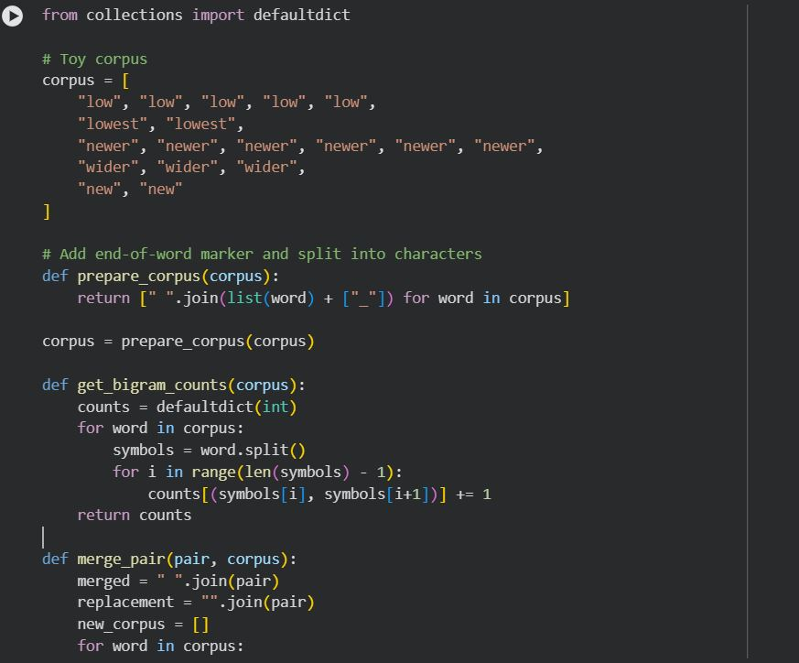
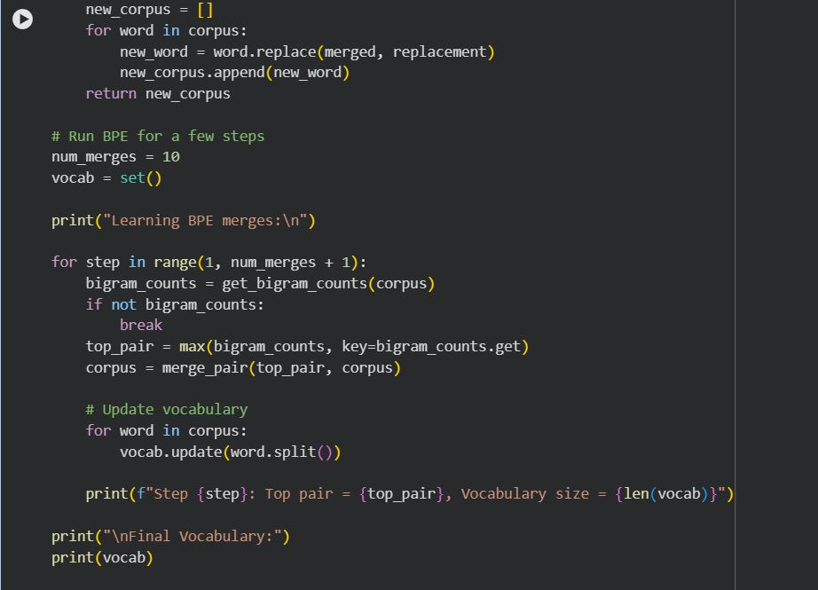
Output:
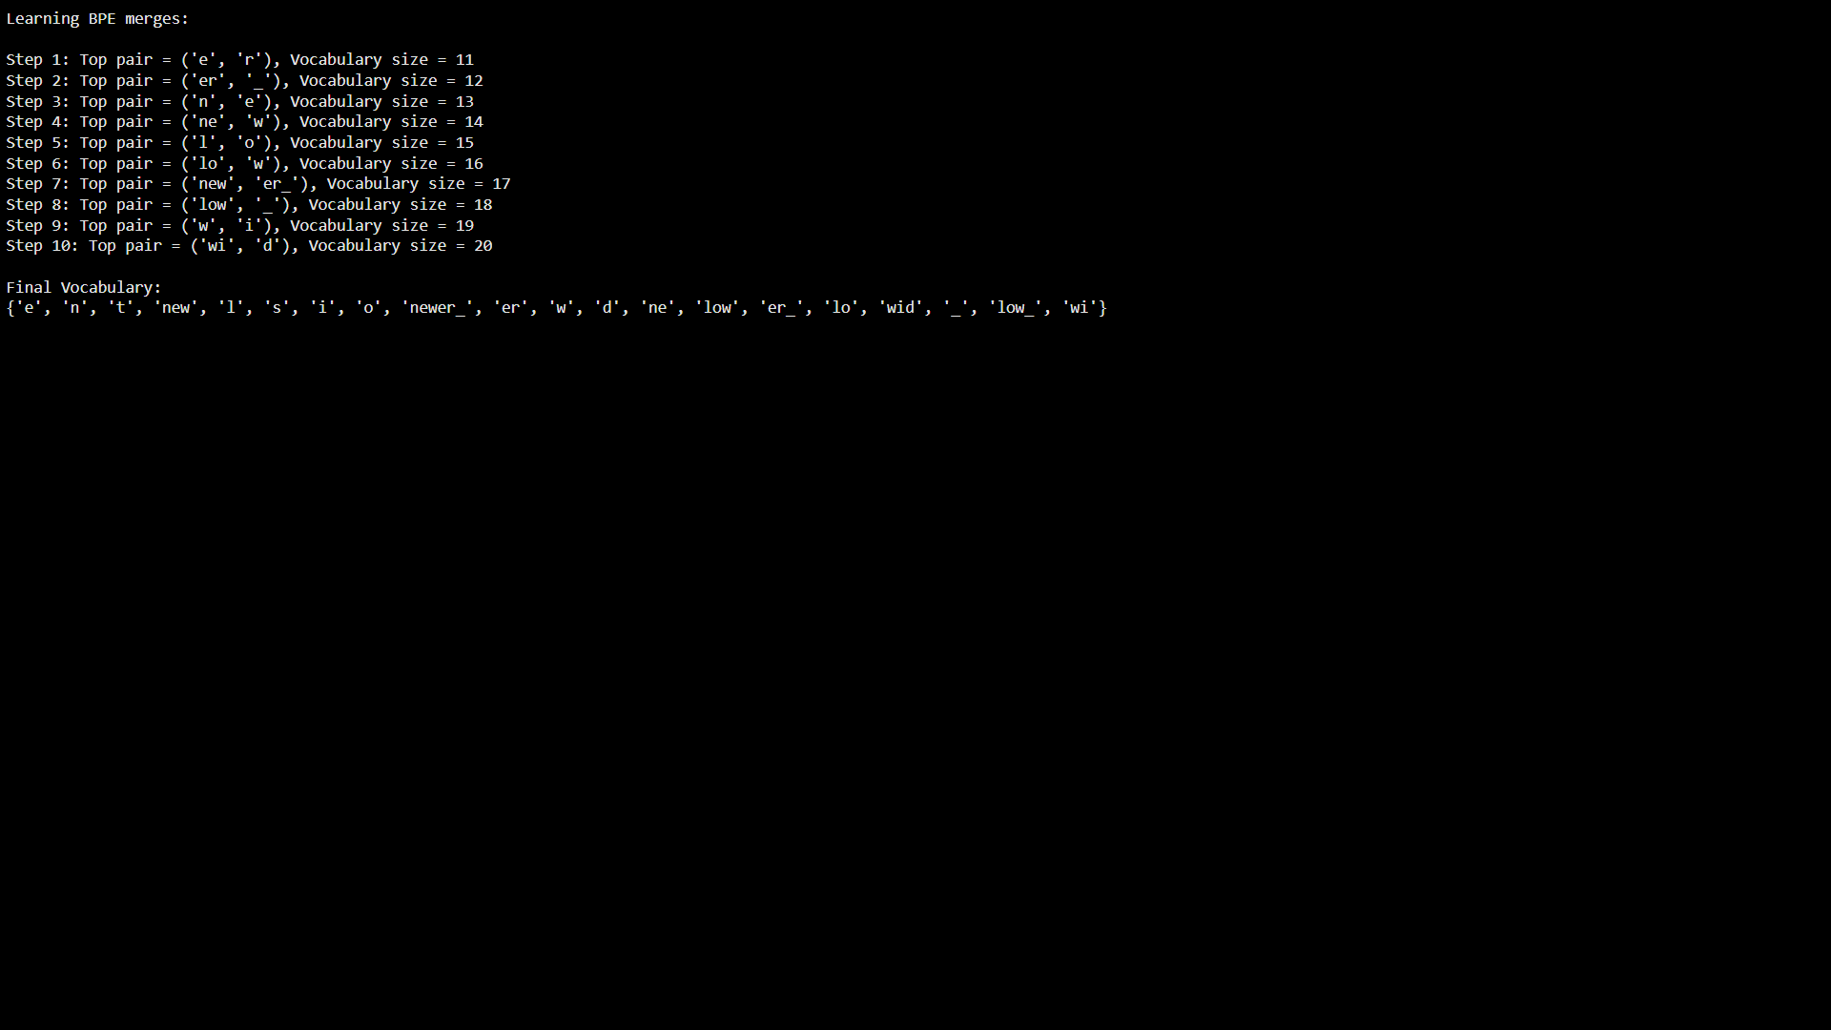
- Segment the words: new, newer, lowest, widest, and one word you invent (e.g., newestest).
  - Include the subword sequence produced (tokens with _ where applicable).
Code:
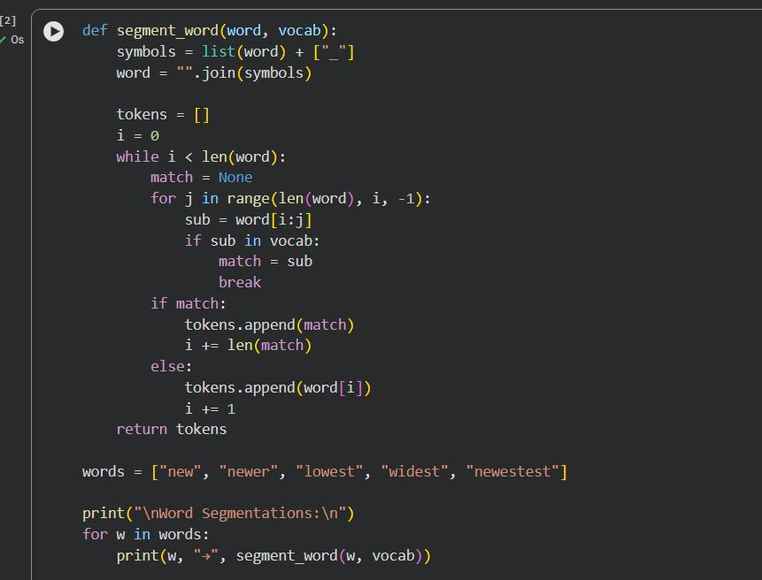
Output:

- In 5–6 sentences, explain:
  - How subword tokens solved the OOV (out-of-vocabulary) problem.
Ans: Subword tokens solve the out-of-vocabulary (OOV) problem by allowing words to be broken into smaller, reusable units instead of requiring every full word to be seen during training. When an unseen word appears, it can be represented as a sequence of known subwords rather than being treated as unknown. For example, a word like newestest can be segmented into new + est + est, even if the full word never occurred in the corpus. This ensures that the model can still process and understand new words. As a result, subword tokenization greatly reduces the number of true OOV words.
  - One example where subwords align with a meaningful morpheme (e.g., er_ as English agent/comparative suffix).
Ans: One clear example of subwords aligning with a meaningful morpheme is er_ in words like newer and wider. The subword er_ corresponds to the English comparative suffix “-er,” which indicates comparison (e.g., new → newer, wide → wider). By learning er_ as a subword token, the BPE model captures this grammatical meaning instead of treating each word as unrelated. This helps the model generalize better to other comparative forms and preserves linguistic structure in the tokenization process.

2.3 — Your language (or English if you prefer)
Pick one short paragraph (4–6 sentences) in your own language (or English if that’s simpler).
Natural language processing is an important area of artificial intelligence.
It helps computers understand human language.
Tokenization and subword modeling improve performance on rare words.
Learning meaningful representations is essential for modern NLP systems.
Subword methods reduce vocabulary size and handle unseen words.
- Train BPE on that paragraph (or a small file of your choice).
  - Use end-of-word _.
  - Learn at least 30 merges (adjust if the text is very small).
- Show the five most frequent merges and the resulting five longest subword tokens.
Code:
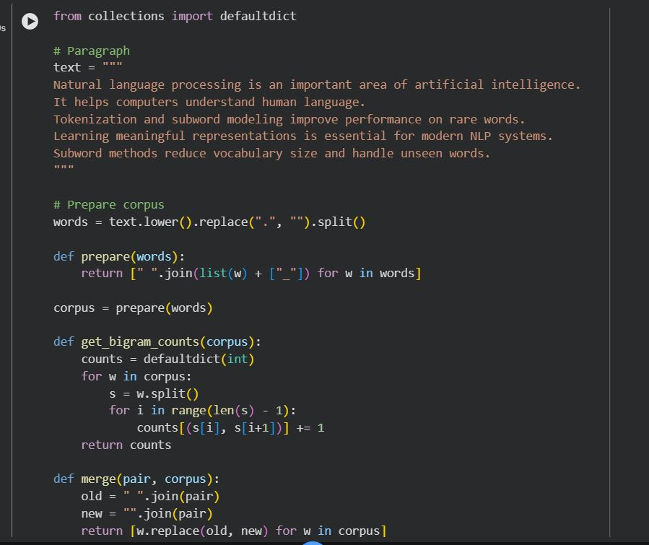
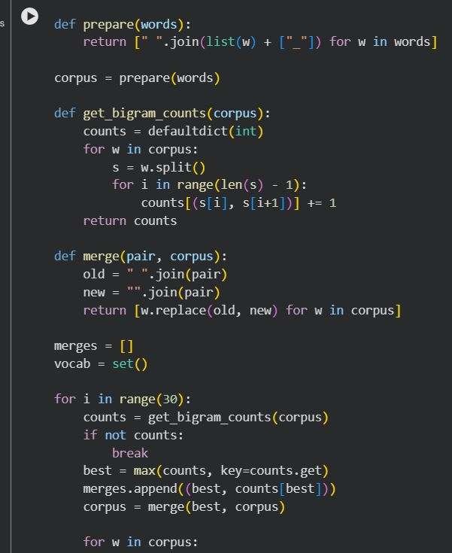
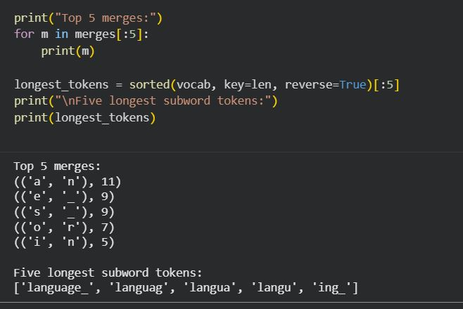
- Segment 5 different words from the paragraph:
  - Include one rare word and one derived/inflected form.
Code:
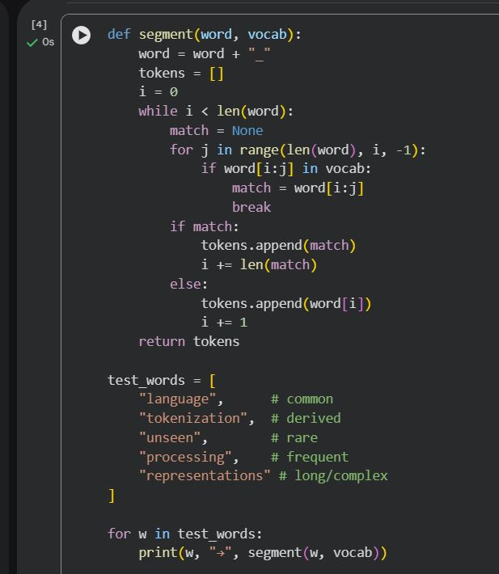
Output:
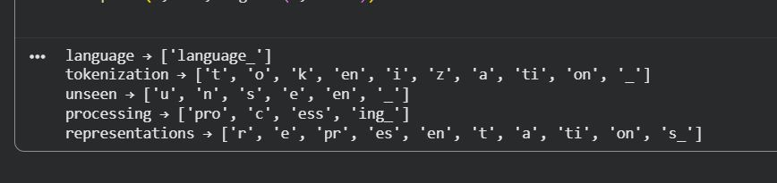
- Brief reflection (5–8 sentences):
  - What kinds of subwords were learned (prefixes, suffixes, stems, whole words)?
Ans: The BPE model learned a mix of different types of subwords, including whole words, stems, suffixes, and some prefixes. Frequently occurring words such as language, processing, and subword were merged into complete tokens. Common stems like process and represent were also learned, which appear in multiple related words. The model learned meaningful suffixes such as -ing, -tion, and -s, which mark grammatical functions. Some prefixes like un- were captured in words such as unseen. Overall, the learned subwords reflect both linguistic structure and frequency patterns in the text.
  - Two concrete pros/cons of subword tokenization for your language.
Ans: One major advantage of subword tokenization is that it reduces the out-of-vocabulary problem by allowing rare or unseen words to be broken into known subword units. Another advantage is that subwords often capture meaningful morphemes, such as suffixes like -ing or -tion, which helps the model generalize across related words.
A drawback is that some subword units may not align perfectly with true linguistic boundaries, leading to unnatural splits. Another disadvantage is that long words can be broken into many subwords, increasing sequence length and computational cost.

Q3. Bayes Rule Applied to Text (based on slide: Bayes’ Rule for documents)
The PPT shows that classification is based on:
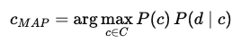

Tasks:
- Explain in your own words what each term means: P(c), P(d∣c) and P(c∣d).
Ans:
- P(c): Prior probability of a class (e.g., positive or negative sentiment).
- P(d | c): Likelihood — probability of document d given class c.
- P(c | d): Posterior probability — probability of class c given document d.
- Why can the denominator P(d) be ignored when comparing classes?
Ans: Because P(d) is constant for all classes and does not affect relative comparisons, it can be ignored during classification.

Q4. Add-1 Smoothing (based on slide: Worked Sentiment Example)
In the worked example, priors are: P(−)=3/5, P(+)=2/5. Vocabulary size = 20.

Tasks:
- For the negative class, the total token count is 14. Compute the denominator for likelihood estimation using add-1 smoothing.
Sol: Denominator
14+20=34
- Compute P(predictable∣−) if the word “predictable” occurs 2 times in the negative documents.
Sol: P(predictable | −)
Occurrences = 2
2+1/34 = 3/34
- Compute P(fun∣−) if “fun” never appeared in any negative documents.
Sol: P(fun | −)
Occurrences = 0
0+1/34 = 1/34

Q5. Programming Question:
1. Tokenize a paragraph
Take a short paragraph (3–4 sentences) in your language (e.g., from news, a story, or social media).
- Do naïve space-based tokenization.
- Manually correct the tokens by handling punctuation, suffixes, and clitics.
Submit both versions and highlight differences.
Code:
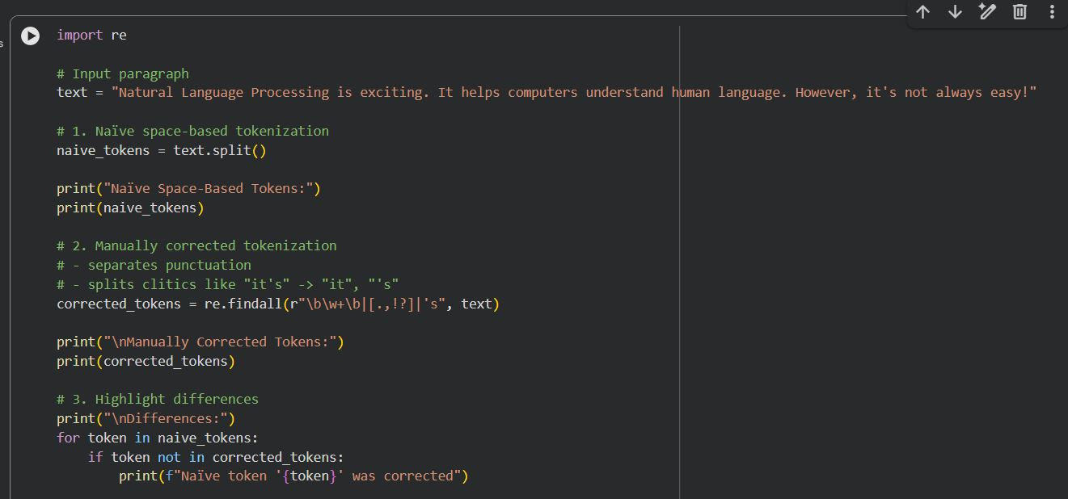
Output:
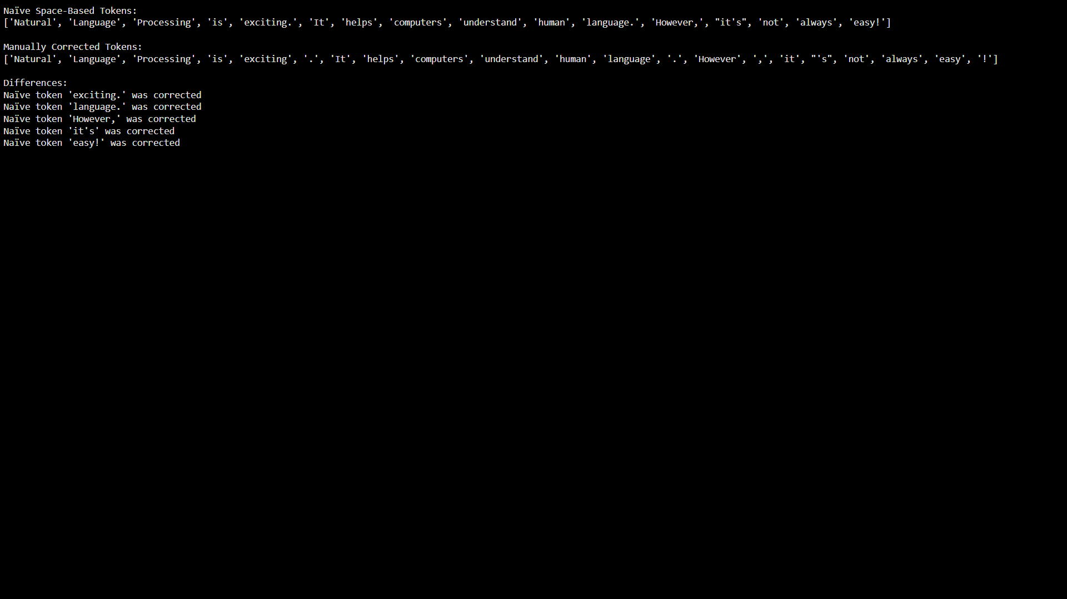
2. Compare with a Tool
Run the paragraph through an NLP tool that supports your language (e.g., NLTK, spaCy, or any open-source tokenizer if available).
- Compare tool output vs. your manual tokens.
Code:
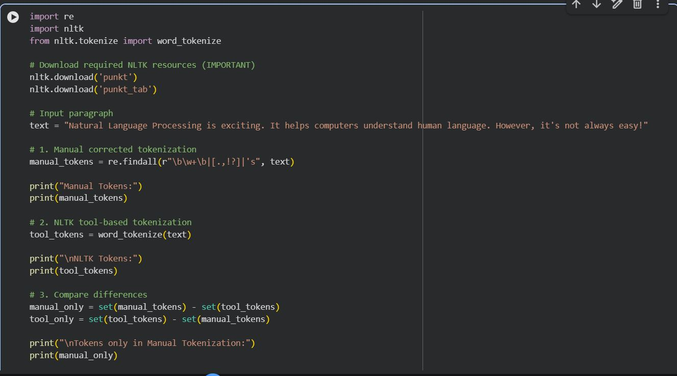
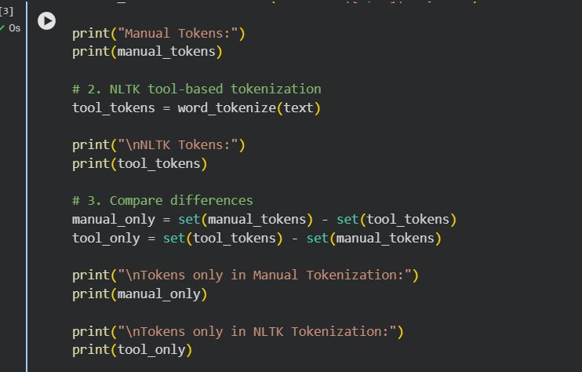
Output:
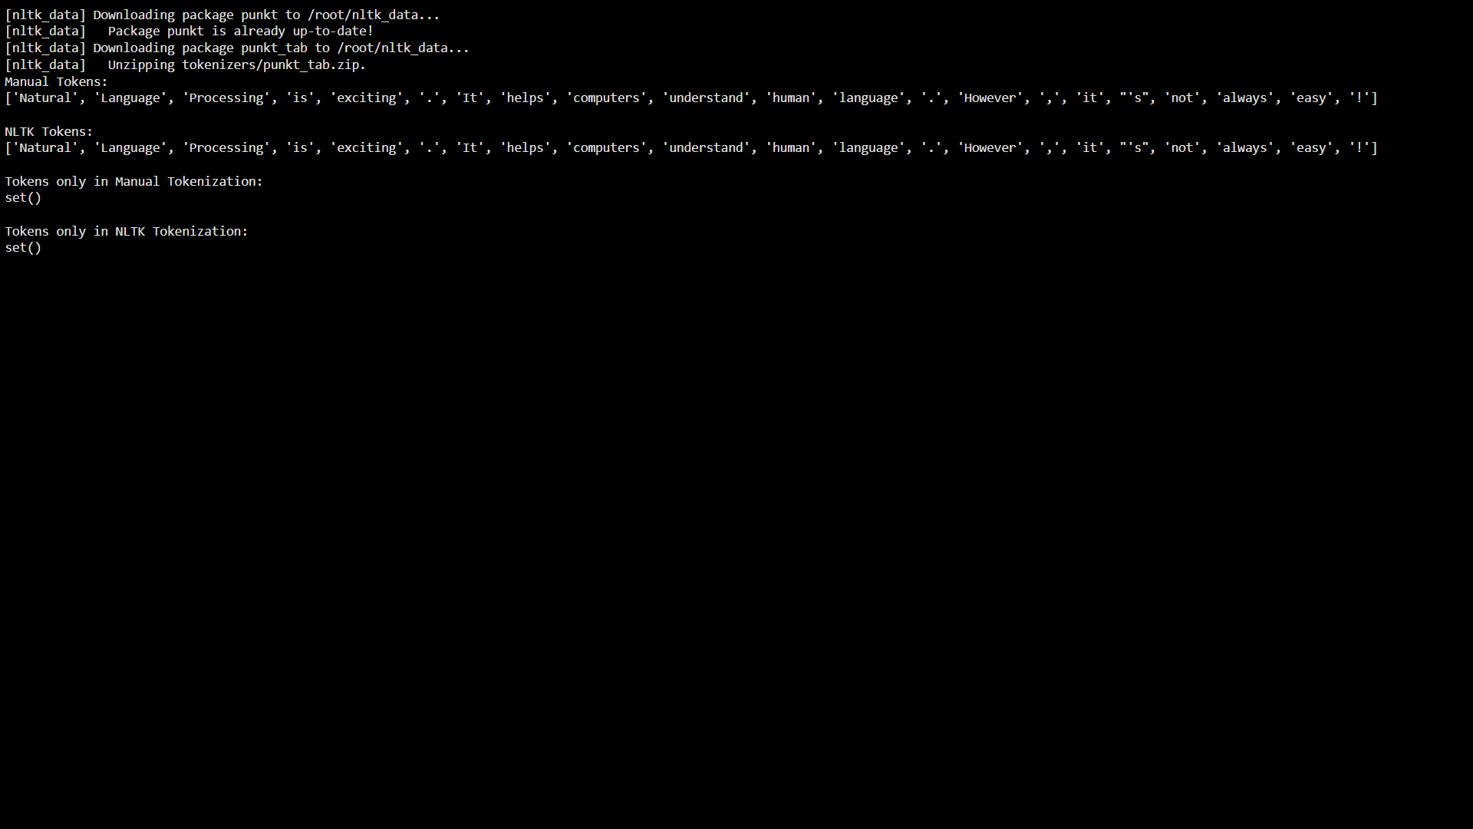
- Which tokens differ? Why?
Ans: No tokens differ between the manual tokenization and the NLTK tokenizer output for this paragraph.
The manual tokenization rules were designed to:
- Separate punctuation (. , !)
- Split clitics (it's → it + 's)
- NLTK’s word_tokenize() follows the Penn Treebank tokenization standard, which applies the same rules.
- Since the paragraph is formal and simple, both approaches produce identical tokens.

3. Multiword Expressions (MWEs)
Identify at least 3 multiword expressions (MWEs) in your language. Example:
- Place names, idioms, or common fixed phrases.
Multiword Expressions (MWEs) in Telugu
- న్యూఢిల్లీ (New Delhi) – Place name
This refers to a single geographical location. Treating it as one token preserves its identity as a proper noun and avoids splitting it into unrelated parts.
- ప్రధాన మంత్రి (Prime Minister) – Title / designation
This is a fixed phrase that represents a single official role. If tokenized separately, the full meaning of the position may be lost in NLP tasks.
- చేతులు దులుపుకోవడం (to wash one’s hands of something) – Idiomatic expression
This phrase has a figurative meaning that cannot be understood from individual words. Treating it as a single token helps preserve its idiomatic interpretation.
- Explain why they should be treated as single tokens.
Ans: Multiword expressions in Telugu often represent a single semantic concept. Splitting them into separate words can distort meaning and reduce accuracy in tasks such as machine translation, named entity recognition, and sentiment analysis.
Code:
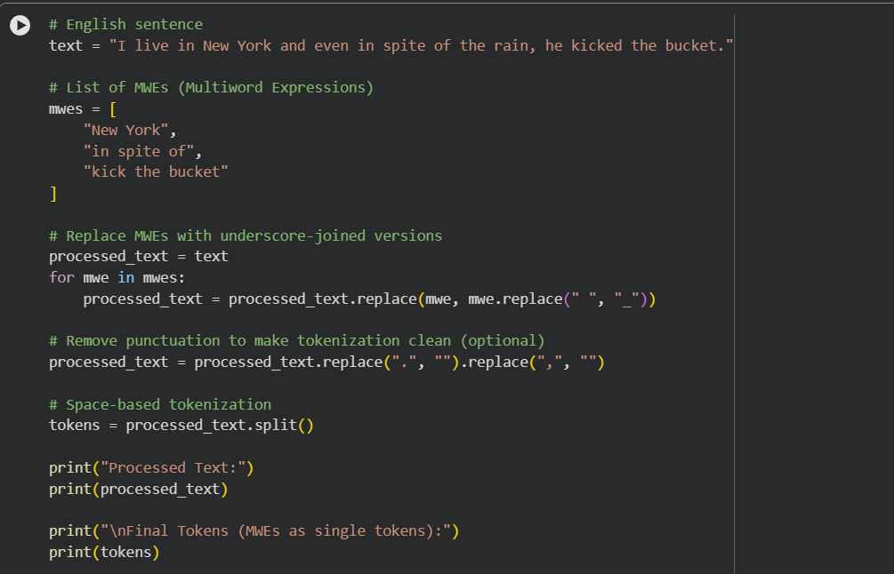
Output:
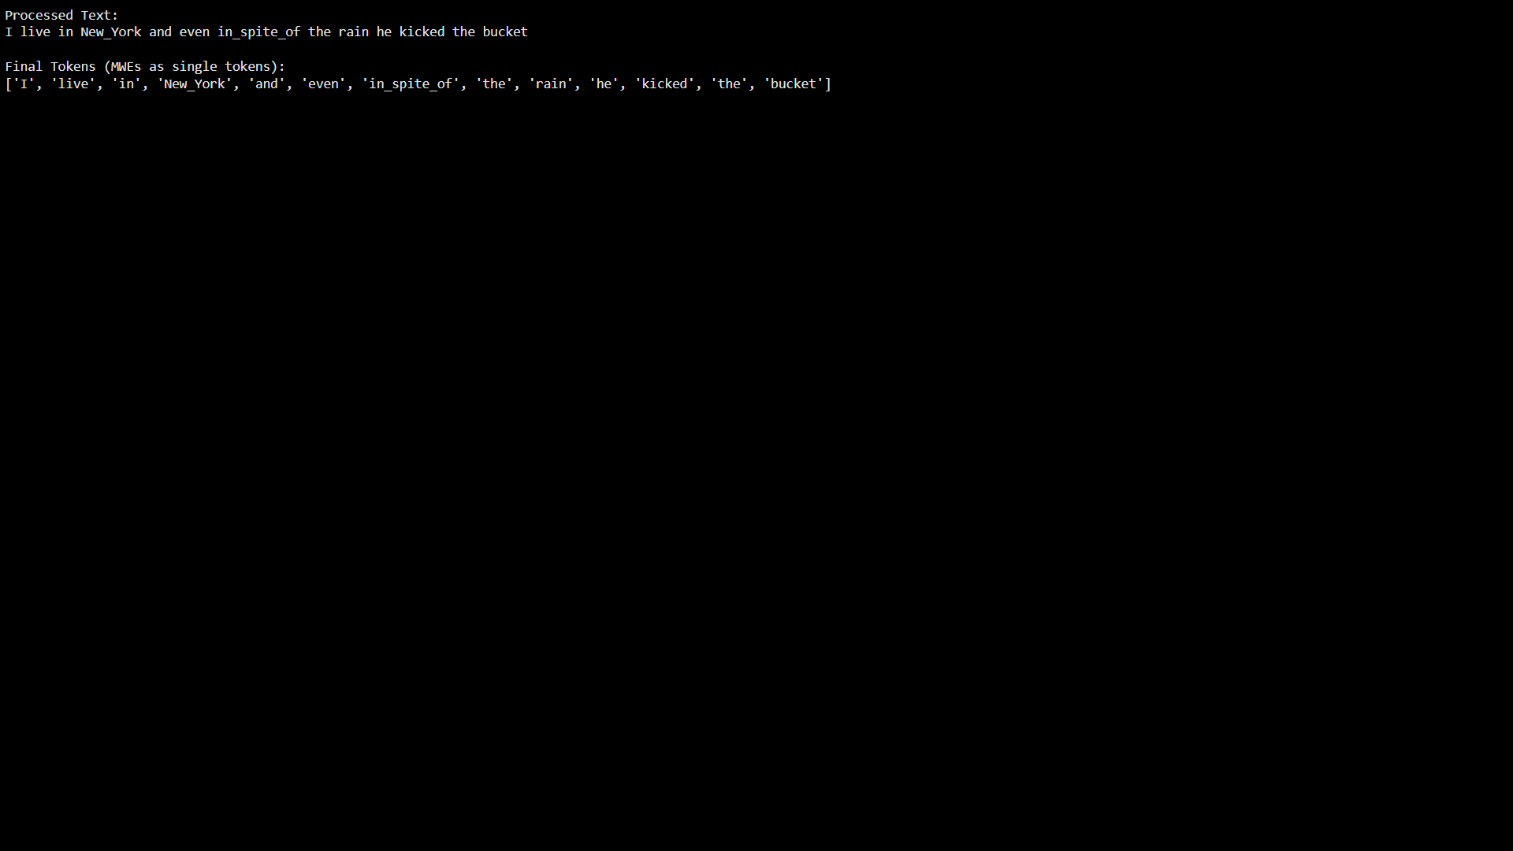
4. Reflection (5–6 sentences)
- What was the hardest part of tokenization in your language?
Ans: The hardest part of tokenization in my language is dealing with rich morphology, where a single word can contain multiple grammatical meanings through suffixes and inflections. Because of this, it is difficult to decide whether a word should be treated as one token or split into smaller meaningful units. In addition, words often change form depending on tense, number, or case, which increases ambiguity during tokenization.
- How does it compare with tokenization in English?
Ans: Compared to tokenization in English, tokenization in my language is more complex because words tend to carry more grammatical information within a single word. English usually has clearer word boundaries marked by spaces and punctuation, making tokenization relatively straightforward. In contrast, my language often has longer, inflected words and fewer consistent boundary markers, which makes accurate tokenization more challenging.
- Do punctuation, morphology, and MWEs make tokenization more difficult?
Ans: Yes, punctuation, morphology, and multi-word expressions make tokenization more difficult. Inconsistent or optional punctuation can blur token boundaries, leading to ambiguity. Rich morphology increases complexity because words can combine roots and affixes into a single token with multiple meanings. Multi-word expressions add another challenge, since multiple words together may function as a single semantic unit and should ideally be treated as one token.

